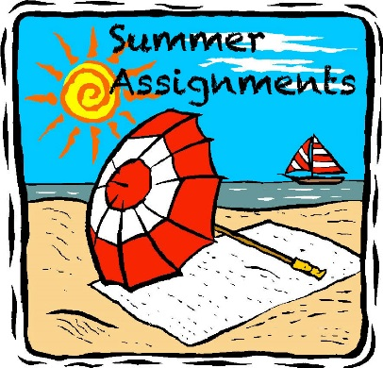

Dear Parents,

Recently, I discussed with the class the reading assignments which all students entering sixth grade need to complete over the summer months. These assignments will help your child review and maintain skills. These assignments are mandatory and must be submitted on Tuesday, September 4, the first day of school. Assignments will be posted on the school website before the end of the school year.

Please review the reading requirements and sign your acknowledgement at the bottom portion of this memo or the suggested reading list and return it by Friday June 8, 2018

Sincerely,
Mrs. McDonnell
==================================================

I am aware of the reading assignments my child needs to complete. Additionally, I understand that the assignments are available on the St. Peter School website and that I am responsible for printing any of the assignment materials that need to be submitted on the first day of school, Tuesday, September 4, 2018.

Student’s Name - _______________________________________________

Parent’s Signature - _____________________________________________

Date: ___________

